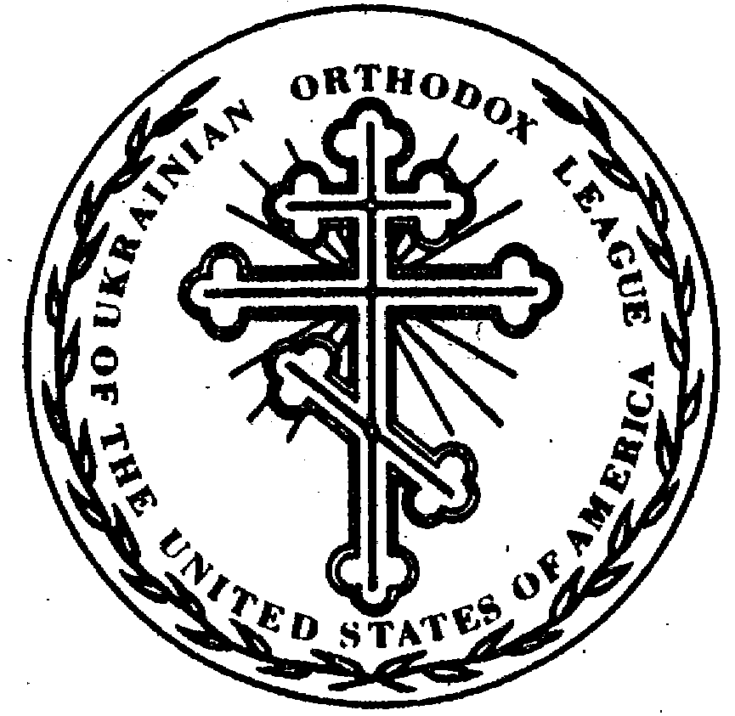
72nd Annual Ukrainian Orthodox League Convention
58th Annual Junior Ukrainian Orthodox League Convention

Schedule
August 1st– 4th, 2019

“Train up a child in the way he should go, and when he is old, he will not depart from it.”

Proverbs 22:6

Thursday, August 1st, 2019

 | SENIOR SESSIONS | JUNIOR SESSIONS
3:00-9:00 PM | Registration (Under the Tent)
4:00 PM | Senior Executive Board Meeting (Millennium Building) | Junior Executive Board Meeting (Dining Hall)
5:45 PM-6:45 PM | Dinner (Dining Hall)
7:00-9:00 PM | Pre-Junior Activities (Millennium Building Lounge)
7:00 PM | Business Session I – Combined Jr./Sr. (Millennium Building)  1. Call to Order  2. Invocation and Blessing  3. Moment of Silence  4. Pledge of Allegiance and U.S. National Anthem  5. Introduction of Hierarchs, Clergy and Special Guests  6. Welcoming Remarks  - John Holowko, Senior UOL President  - Alexis Naumenko, Junior UOL President  - Michael Nakonachny, 72nd UOL Convention Chair  - Rev. Taras Naumenko, Spiritual Adviser  - Rev. John Charest, Review of Junior UOL Convention Rules | Juniors and Seniors meet jointly for the first hour
7:45 PM | Juniors leave to begin Junior Business Sessions | Junior Business Session I – (Dining Hall)
7:50 PM | 7. Roll Call and Credentials Report  8. Appointment of Convention Secretaries, Parliamentarian,  and Sergeant-at-Arms  9. Determination of late fees and recipient  10. Explanation of workshops & committees  11. Approval of the Convention Agenda  12. Hierarchical Address - His Eminence Metropolitan  Antony  13. Approval of 71st Annual Convention Minutes  14. Audit Results 2018-2019  15. Financial Reports 2018-2019 and Preliminary 2019-2020  Operating Budget (to be approved Saturday)  16. Annual Reports 2018-2019  17. Nominating Committee Process and Forms | - Call to order  - Opening Prayer  - Approval of Agenda  - Roll Call and Credentials Report  - Introductions  - Review of Convention Business Session Protocol  7. Appointment of Sergeant-at-Arms, Convention  photographer and establishment of late fines  8. Review of the 57th Annual UOL Convention Minutes  9. Ice Breaker  10. Formation of Chapter Challenge Teams  11. Formation of Committees  12. Nominating Committee Process and Forms
9:00 PM | Recess for most of us  Chaperone Meeting (Dining Hall) | Recess for most of us  Chaperone Meeting (Dining Hall)
9:30 PM | Evening Prayers and Confessions – St. Thomas Chapel | Evening Prayers and Confessions – St. Thomas Chapel
10:00 PM | Hospitality Night/Bonfire, Hosted by 72nd Convention Committee | Hospitality Night/Bonfire, Hosted by 72nd Convention Committee
10:00 PM-11:45 PM | Games at the Dining Hall | Games at the Dining Hall
12 Midnight | Curfew for Juniors is 12:00 midnight (Millennium Building) | Curfew for Juniors is 12:00 midnight (Millennium Building)

Van Departures To/From Hotel

5:15 PM from the Hotel to All Saints Camp
10:30 PM from All Saints Camp to the Hotel
11:30 PM from All Saints Camp to the Hotel

Contact Information: Camp Manager’s Office: 724-867-5811
Dining Hall: 724-867-9911

Friday, August 2nd, 2019

 | SENIOR SESSIONS | JUNIOR SESSIONS
7:30 AM | Confession (St. Thomas Chapel) | Confession (St. Thomas Chapel)
8:00 AM | Divine Liturgy (St. Thomas Chapel) | Divine Liturgy (St. Thomas Chapel)
10:00 AM | Brunch (Dining Hall) | Brunch (Dining Hall)
11:00AM-5:00 PM | Registration (Under the Tent)
11:30AM-5:00 PM | Pre-Junior Activities (Millennium Building Lounge)
11:30 AM | Business Session II – (Millennium Building)  - Roll Call  - Credentials Report  - Fr. John Haluszczak, All Saints Camp  - Keynote Address and Q & A with Dr. Albert Rossi  “Finding Your Peace” | Juniors and Seniors meet jointly until 1:30 PM through Keynote Address
1:30 PM-1:45 PM | Break
1:45 PM-2:30 PM | Break-out Sessions/Committee Meetings (Session 1)  - Prayer Life in Our Daily Lives.  - Christian Caregiving: Immigration/challenges/opportunities and future projects of focus.  - Membership: UOL relationship with Clergy & Chapter Revitalization; true issues and overcoming obstacles.  - Nominations | Business Session II (Dining Hall)  - Roll Call & Credentials Report  - Defined Committees meet  - Preliminary Chapter Challenge Rounds  - Service Project  - Hierarchical Address-  Questions/ Real challenges on Keynote address
2:30 PM-3:15 PM | Break-out Sessions/Committee Meetings (Session 2)  - Prayer Life in Our Daily Lives.  - Christian Caregiving: Immigration/challenges/opportunities and future projects of focus.  - Membership: UOL relationship with Clergy & Chapter Revitalization; true issues and overcoming obstacles.  - Nominations. | Business Session II Continues (Dining Hall)
3:15 PM-4:00 PM | Break-out Sessions/Committee Meetings (Session 3)  - Prayer Life in Our Daily Lives.  - Christian Caregiving: Immigration/challenges/opportunities and future projects of focus.  - Membership: UOL relationship with Clergy & Chapter Revitalization; true issues and overcoming obstacles.  - Nominations. | Prayer Ropes project with Ms. Victoria Swindle
4:00 PM 4:15 PM | Break
4:15 PM-5:00 PM | 5. Presentation: “Souper Bowl Sunday” donation to the St.  Andrew Society  - 6. Presentation of Essay Contest Awards  - 7. Future Convention and Bids  - 2020 Philadelphia Presentation  - 2021 Open  - 2022 Carnegie -Bid to be formally accepted | Juniors join Senior Business Session 4:15PM
5:00 PM | Recess | Recess
6:00 PM | Dinner (Ukrainian Food Trucks) Dining Hall Area
7:00 PM-8:45 PM | Dance (Pavilion)
7:00 PM-8:45 PM | Volley Ball/Pool
9:00 PM | Evening Prayers (St. Thomas Chapel)
9:30 PM-11:15 PM | Hospitality Night, hosted by the Philadelphia 73rd Convention Committee– (Millennium Building Upper Level) | Hospitality Night, hosted by the Philadelphia 73rd Convention Committee– (Millennium Building Lounge)
12 Midnight | Curfew for Juniors is 12:00 Midnight | Curfew for Juniors is 12:00 Midnight
Van Departures To/From Hotel

7:15 AM from the Hotel to All Saints Camp
10:30 PM from All Saints Camp to the Hotel
11:30 PM from All Saints Camp to the Hotel

Contact Information: Registration: 724-867-5811
Dining Hall: 724-867-9911

Saturday, August 3rd, 2019

 | SENIOR SESSIONS | JUNIOR SESSIONS
8:00 AM | Akathist to the Mother of God of Pochayiv (St. Thomas Chapel) | Akathist to the Mother of God of Pochayiv (St. Thomas Chapel)
8:45 AM | Breakfast (Dining Hall)
9:30 AM-12:00 PM | Registration – Tickets
9:30 AM-12:00 PM | Pre-Junior Activities (Millennium Building Lounge)
9:30 AM-11:15 PM | Business Session III (Millennium Building)  - Roll Call and Credentials Report  - Committee Reports  - Hierarchical Address - His Eminence Archbishop Daniel  - Approval of 2019-2020 Budget  - Unfinished and New Business  - Comments from National Executive Board Members  - Nominating Committee Report-Election  - SOBOR 2019-Delegate & Alternate Selection | Business Session III (Dining Hall)  - Roll Call and Credentials Report  - Finalizing All Committee Reports  - Elections
11:15AM-12:00 PM | - Final Round of Chapter Challenge in Senior Business Sessions  - Junior Convention Committee Reports  - Presentation of Junior Elections Report  - Presentation of Service Project  - Announcements  - Adjournment  - Closing prayer and Ukrainian National Anthem | Juniors join Senior Business Session near 11:15AM
12:00 PM | Convention Picture
12:15 PM | Lunch-Dining Hall
1:00 PM | Meeting of the Old and New Executive Boards (Millennium Building) | Meeting of the Old and New Executive Boards (Millennium Building Lounge)
1:00 PM-3:00 PM | Various Camp Activities & Workshops  Kickball, Volleyball, Swimming | Various Camp Activities & Workshops  Kickball, Volleyball, Swimming
1:15 PM -3:00 PM | “Orthodoxy on Tap” with His Eminence Archbishop Daniel as Moderator “Why Orthodoxy and Not Just Christianity” (Dining Hall) | Various Camp Activities & Workshops  Kickball, Volleyball, Swimming
3:15 PM | Vespers (St. Thomas Chapel) | Vespers (St. Thomas Chapel)
6:00 PM | Grand Banquet and Ball – – Opening Reception Hour -Grove City Country Club | Grand Banquet and Ball – – Opening Reception Hour -Grove City Country Club
7:00 PM-11:30PM | Grand Banquet and Ball-GCCC | Grand Banquet and Ball-GCCC
1:00 AM | Curfew for Juniors is 1:00 AM | Curfew for Juniors is 1:00 AM

To/From Grove City Country Club
5:00 PM from Hotel & All Saints Camp
1st Bus 9:30 PM from GCCC to Hotel
2nd Bus 11:45 PM from GCCC to All Saints Camp
To/From Hotel
7:30 AM from the Hotel to All Saints Camp
2:00 PM from All Saints Camp to the Hotel
3:45 PM from All Saints Camp to the Hotel

Sunday, August 4th, 2019

8:30 AM | Greeting of the Hierarchs (St. Thomas Chapel)
8:45 AM | Hierarchical Divine Liturgy (St. Thomas Chapel)
11:15 PM | Farewell Luncheon –after Divine Liturgy (Dining Hall)
12:30 PM | Departure

Please Drive Your Vehicles to St Thomas’ Chapel Sunday Morning-No Shuttle Service

Please Travel Safely-See you Next Year in Philly!

