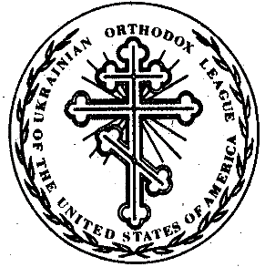Ukrainian Orthodox League

Of the Ukrainian Orthodox Church of the U.S.A.

**SENIOR CHAPTER DUES PAYMENT FORM**

Chapter: ____________________________________________

City and State: ____________________________________________

Enclosed are the following:

1. Chapter Dues $125.00 $__________
2. Member Dues _________ x $25.00 = $__________
3. Chapter Project Donation $__________
4. Other $__________

Check Number __________ **Total:** __________

Membership Roster: _____Enclosed _____Emailed

Name: ____________________________________________

Position: ____________________________________________

Telephone: ____________________________________________

Email: ____________________________________________

Please send this form, payment, and chapter membership roster to:

UOL Financial Secretary

Oleh Bilynsky

703 Pine Ridge Rd.

Media, PA 19063

(610) 892-7315

[nsufler@aol.com](mailto:nsufler@aol.com)